# Iceland: Colorful, Cold, and Charming

Places mentioned in this post:

Milan, Italy

Vogar, Iceland

Reykjavik, Iceland

Keflavik, Iceland

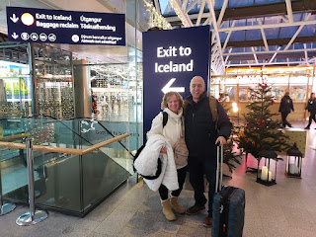

We checked another bucket-list item off our wish list recently by visiting Iceland for two days on our way to America. We found some amazing ticket prices that weren't initially on our radar, and they were just too good to pass up. Something I have learned is that if you don't find a good price from your top choice airport, try looking at a few airports a little further out.

In our case, we always try to fly in and out of Venice because it's the closest airport and therefore convenient. But there might be another good option out of Bologna or Milan, so it's been helpful to check out their flight schedule and prices, too. We found an incredible deal on EasyJet from Milan to Reykjavik that was not only nonstop, but it was only 26 euros each way!! The next leg surprised us, too, because there was a direct flight from Reykjavik into Minneapolis - with NO LAYOVERS!! I bought a one-way ticket to Minneapolis for just $422, while Scott's round trip ticket was in the $800 range. *For comparison, I often pay around $1200 for a round trip ticket to and from Idaho Falls to Venice, but with two stops along the way and lots of sitting for hours on end.

We've decided that with the ease of this flight path + the amazing ticket prices, we will probably make this our new routine. Iceland has so much to offer and we had a blast during those two days. Plus, if we can grab a direct flight into Minnneapolis to see our grandchildren more regularly, all the better! It was a 4 hour flight from Milan to Reykjavik, and then it was a 6 hour flight into Minneapolis. Piece of cake.

Our travels began with a 2.5 hour drive to Milan, though . . . so we are considering taking the train next time, especially if we have less luggage to haul than what we had this time. I had my usual 90 days' worth of stuff, PLUS a few Christmas items, PLUS Maisie's new blanket, etc. It was a lot. It wouldn't have been fun to haul all of those things on a bus, to a train, to another train, to an eventual airport.

Monday, November 25th:

We gave ourselves plenty of time to travel by car to Milan, which was wise because you never know if there might be an accident or something else to slow things down on the freeway. We left around 7:15 a.m., just as the sun was coming up.

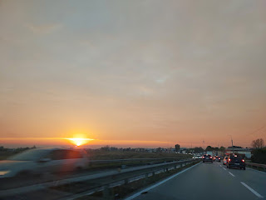

The parking lot Scott booked online ahead of time was a piece of cake. The shuttle to the airport was a piece of cake. Checking our luggage in was a piece of cake. And EasyJet Airlines was WAY better than RyanAir. (Anyone is better than RyanAir . . .) They were super helpful and had plenty of staff to get us through the process and onto our plane.

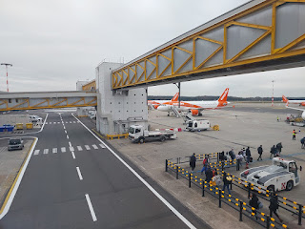

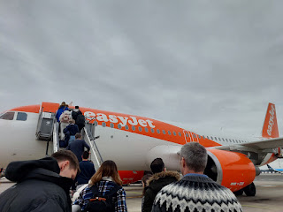

We ended up having an empty seat in between us on the way to Reykjavik, so we sprawled out a little more than we would have otherwise. BONUS.

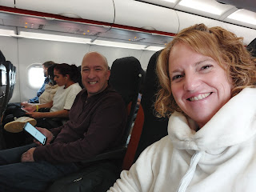

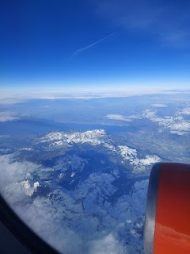

Up and over the Alps and past the United Kingdom we went . . . As the Iceland shoreline came into view, I could see the smoke from the smoldering volcano that is still currently active (as of this writing).

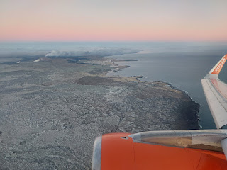

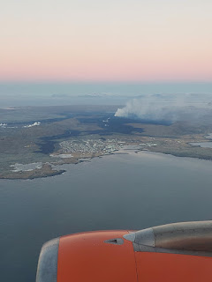

Video of the lava flow near the Blue Lagoon: (10 seconds)

https://photos.app.goo.gl/kHHV3sR8q7iJP3PA7

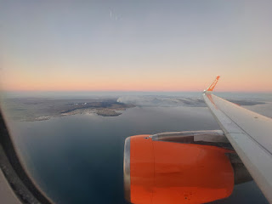

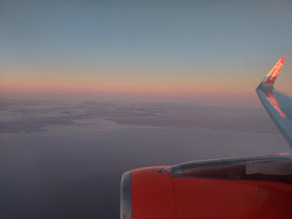

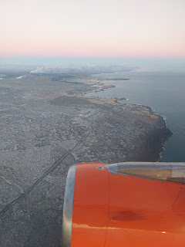

I had a great vantage point out my window, and a young lady across the aisle recognized this, too. She passed her camera phone over to me so I could get some pictures and videos for her. Occasionally, as the plane would circle and change direction, I would indicate for her to pass her phone again so I could get another couple photos or videos for her. She was so grateful!

Video of the somewhat bleak landscape as we came down to land in Keflavik: (9 seconds)

https://photos.app.goo.gl/TH5nMsFoaMt5Pxub8

I was expecting more snow, I guess, but it was more brown than what I had envisioned it to be.

The language is pretty weird in Iceland. It definitely had a Scandinavian flair to it, but I didn't learn until the next day that Denmark and Norway have played a large role in how Iceland came to be.

Take this sign for toilets, for example, ha ha . . .

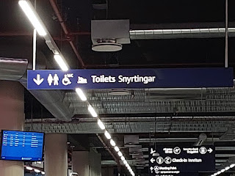

We got our rental car, a 4x4 Suzuki SUV, which, thankfully was on-site at the airport and we didn't have to take a shuttle. A 4-wheel drive vehicle is recommended if you're traveling to Iceland in the winter months. We reserved ours several weeks in advance, ensuring that we would be all set when we arrived.

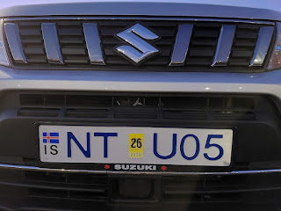

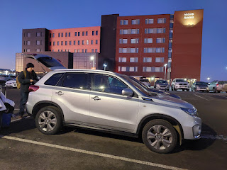

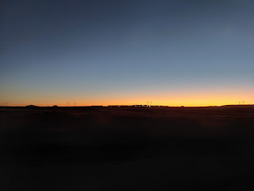

From the Keflavik Airport, it was only a short drive to our hotel in Vogar, about 12 minutes.

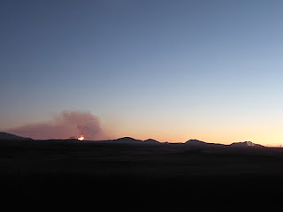

Video of the lava flow as we drove to our hotel: (12 seconds)

https://photos.app.goo.gl/Pi1LpiX8gyemVvd18

If you look at a map of Iceland (Google Maps is great), look for Keflavik, Vogar, the Blue Lagoon, and Grindavik. You'll be able to see how close all of these places are to the lava flow just east of the Blue Lagoon. We had reserved a time slot to soak in their world-renowned thermal spa, but because of the lava flow and the safety concerns, Blue Lagoon evacuated on Nov. 20th and has remained closed for almost 3 weeks now. I saw on the news a couple days ago that the parking lot and a parking attendant shed had been engulfed by the slow-moving lava. We have since been refunded, but our hope is to still go there some day.

Here is a link to an article with recent aerial photos over the Blue Lagoon:

https://mossandfog.com/powerful-photographs-capture-lava-destroying-parts-of-icelands-famous-blue-lagoons/

It is typical to have two twin-sized beds pushed together to form a "queen-sized" bed on the other side of the world. However, most of those places do a better job minimizing the "gap" in between than what we had in Vogar. Often we've seen one large fitted sheet placed over the two beds to unify them. But this time, the frames underneath prevented the beds from scooting up against each other and so we ended up with two very separate beds, ha ha.

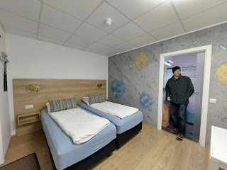

The shower was unique in that it had accordion-style doors with sort of a rubber strip running along the bottom to hold the water in. The bathroom was very tiny overall, but it was functional.

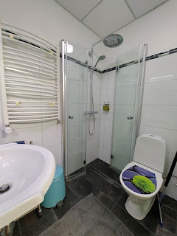

There was even a long-handled squeegee for cleaning up the floor after your shower, if you had any water mess afterwards, that is . . .

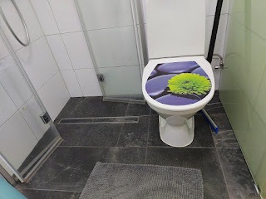

For dinner that night, we had roughly one choice . . . to walk to Kim Yong Wings down the street from our hotel room. Vogar is teeny tiny, so there aren't a lot of options for dining out. We could have driven back to Keflavik, but we chose to just get out and walk for some exercise. It was freezing cold, but then life is an adventure, right? Plus this place was rated 4.8 stars . . .

One side of the menu is in English . . . (Note the pricing next to the items - for currency, they use krona in Iceland, also sometimes seen as "ISK".)

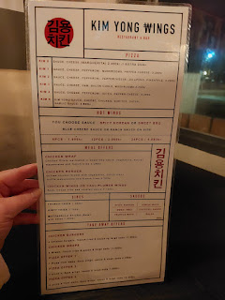

The other side of the menu is in Icelandic . . .

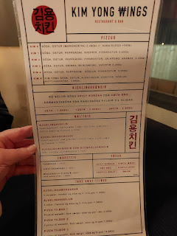

I ordered the chicken burger, while Scott ordered the chicken wrap.

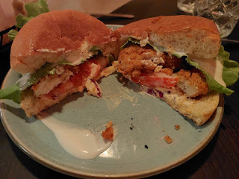

We chose to share the "dirty fries". I didn't like the sauces very much, so I dug down to the bottom for some of the plain fries instead.

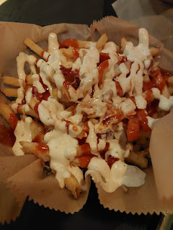

The burger, the wrap, and the fries cost us $60 USD. And yes, you read that correctly. We knew ahead of time that things are pricey in Iceland, but we were surprised that such a simple meal would cost that much!!

Hanging in the restaurant window next to our table were some Christmas wishes in Icelandic . . . "Merry Christmas and Happy New Year!"

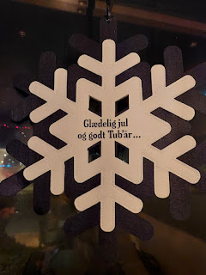

We perused the neighborhood on foot after our meal, to see what we could see before going to bed for the night. We saw more than one 4x4 with giant tires parked in various driveways. I imagine that they would come in super handy when A) the weather is bad, and B) exploring the tough terrain in good weather.

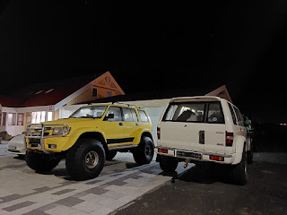

We found the edge of the North Atlantic Ocean at the end of a street in Vogar. We thought we could see Reykjavik in the distance with all the pretty lights, but the next day we realized that what we saw was Alftanes and

Hafnarfjorour, two small towns on a small peninsula between Vogar and Reykjavik.

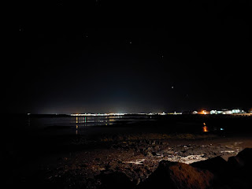

We could also see the volcanic activity about 10 minutes south of Vogar from where we stood. It was very bright and colorful against the dark night sky.

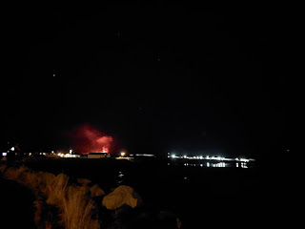

Many of the homes in Vogar reminded me of 1970's ranch style homes, while others were small and cute cottages. Several were decorated with bright Christmas lights and it all felt very welcoming. Christmas is being celebrated and is eagerly anticipated all over the world!

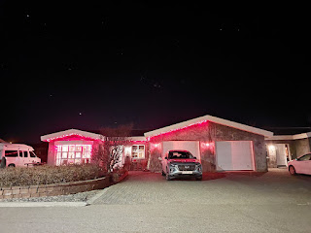

Tuesday, November 26th:

Weirdly, when we woke up, everything was still VERY dark outside. That's when we remembered that in the winter months, daylight only exists for a few short hours each day. Take a look at the sunrise and sunset times below . . .

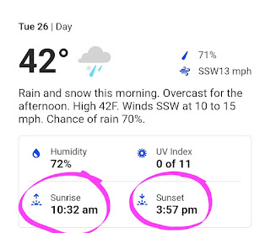

We drove into Reykjavik around 9:00 a.m. and this is what it looked like . . .

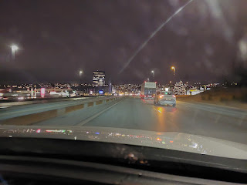

Close to 10:00 a.m. the sky began to get a little lighter . . .

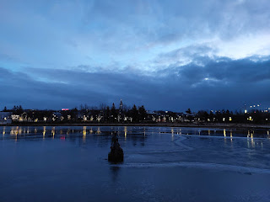

We parked near the University of Iceland and the National Museum of Iceland. It seemed to be a good spot that was close to many of the places we wanted to be for the day. There was a beautiful park across the main road (Hwy 49), with a large lake, a group of swans, and paved trails all the way around.

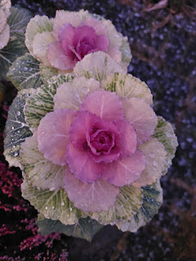

The ornamental cabbage or kale was stunning in the morning sunrise, with droplets of melting ice crystals on the pink and white leaves . . .

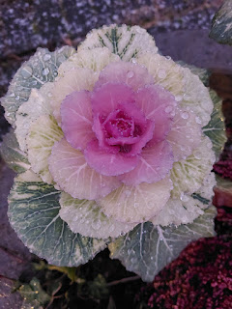

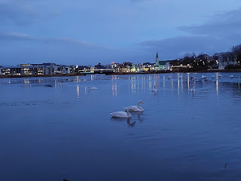

We made our way through the park and up the hill toward

Hallgrimskirkja

, the famous landmark for Reykjavik. (You'll see it in a minute) I loved how even though everything was so dark outside, when the sun

should

have been up, Iceland purposefully decorates everything with white lights all over town to make up for the loss.

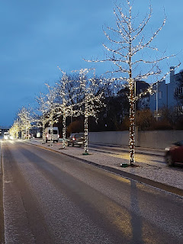

We also saw several Scandinavian-style Christmas stars in the windows of homes, businesses, and restaurants.

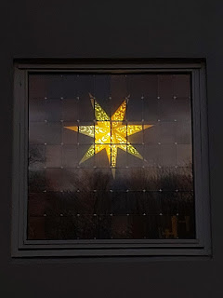

Slight digression: A short summary of how Iceland celebrates Christmas. (Per Wikipedia)

Christmas in Iceland

(

Jól

) starts four weeks before proper

Christmas

, which begins on 24 December (

Aðfangadagur

) and ends thirteen days later on 6 January (

Þrettándinn

, coinciding with

Epiphany

).

Traditionally, one

candle

is lit each Sunday, until four candles are lit on the 24th. At 6:00 p.m.

church bells

ring to start the Christmas celebration. The religiously observant and/or traditional Icelanders will attend

mass

at this time, while the

secular Icelanders

will begin their

holiday meal

immediately. After the meal is finished, they open gifts and spend the evening together. In Iceland, people over the

Yule holidays most often eat

smoked lamb,

ptarmigan

, and turkey. Pork is also very popular.

Thirteen days before 24 December, children will leave their shoes by a window so that the 13 Yule Lads (

jólasveinarnir

) can leave small gifts in their shoes. The Yule Lads are the sons of two

trolls

, Grýla and Leppalúði, living in the Icelandic mountains. Each of the Yule Lads is known for a different kind of mischief (for example slamming doors, stealing meat, stealing milk or eating the candles). Yule Lads traditionally wear early

Icelandic wool clothing

but are now known for the more recognizable

red and white suit

.

Each home typically sets up a

Christmas tree

indoors in the living room, with most decorating it on 11 December. In addition to the decorations, presents are put underneath the tree. It is also a tradition in many homes to boil fish (

skate

) on the 23rd. The day is known as

Saint Thorlak

mass (

Þorláksmessa

).

During the holiday season, it is traditional for families to work together to bake small

cookies

to serve or give to guests. Most common are thin

gingerbread cookies

which are decorated in many different colors of

glaze

. Many families also follow the tradition of making

laufabrauð

, a flat thin bread that is cut out using a special tool and folding technique.

The end of year is divided between two days: the Old Year's Day (

Gamlársdagur

) and the New Year's Day (

Nýársdagur

). At the night of the former and morning of the latter, Icelanders shoot up

fireworks

, blowing the old year away and welcoming the new one.

Thirteen days after the 24th, Icelanders say goodbye to the Yule Lads and other mystical creatures, such as

elves

and trolls. There are

bonfires

held throughout the country while the elves, Yule Lads, and Icelanders dance together before saying goodbye until the next Christmas. This celebration is known elsewhere as

Epiphany Day

.

Isn't it so fun to learn about what other countries and cultures do to celebrate Christmas?!!

We passed by a sculpture garden on our way to the church, so we took a few minutes to wander through and admire the beautiful works of art as the sun continued to wake up. The garden is called: Einar Jonsson Museum and Sculpture Garden.

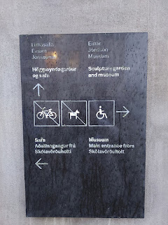

Video looking around the Garden as the church bells rang nearby: (10 seconds)

https://photos.app.goo.gl/H6XT4DqK1MXvmYNB6

"Memorial to a Lost Airliner, 1952"

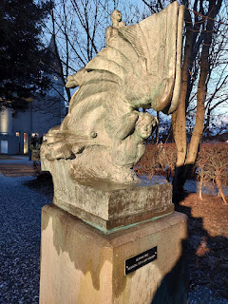

(My favorite one) "Earth", made between 1904-1908.

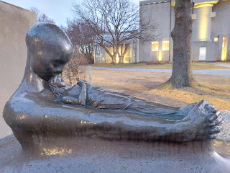

"Spring", made between 1935-1936.

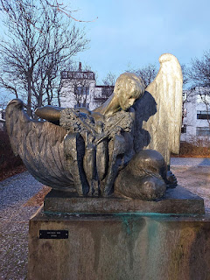

"Thor Wrestling with Age"

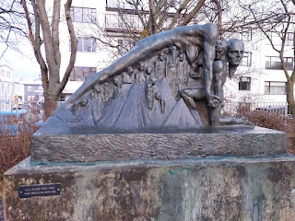

"Christmas", made between 1917-1922.

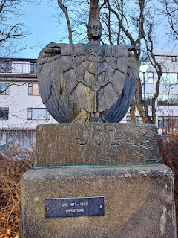

(Another favorite of mine) "Protection", made between 1912-1934.

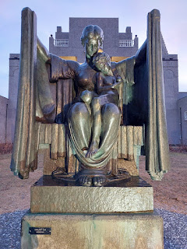

"Sleep", made between 1931-1941.

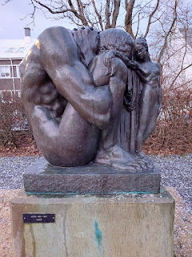

"Light and Shade", made between 1939-1940.

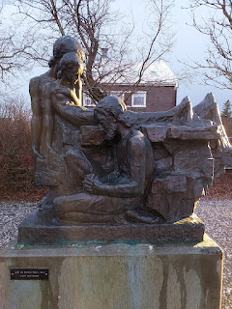

(Another favorite) "Prayer", made in 1939.

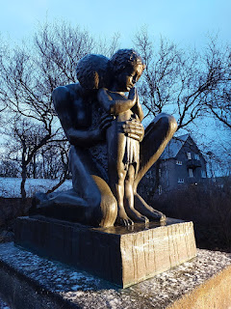

"The End", made between 1906-1938.

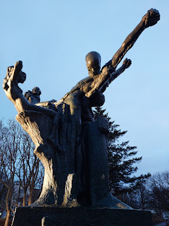

Just a few steps beyond the Sculpture Garden is the iconic and monumental church of Reykjavik. It is called Hallgrimskirkja, and is a Lutheran parish church. It took 41 years to build, between the years of 1945 and 1986. We did not go inside this time, as we intended to either go back later that day or the following day, but our adventures ended up taking us elsewhere. We will definitely be going back to Iceland in the near future, so I imagine we will make it a priority at that time.

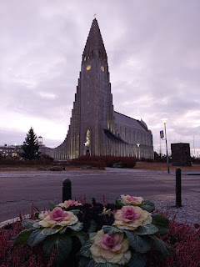

More of that beautiful cabbage . . .

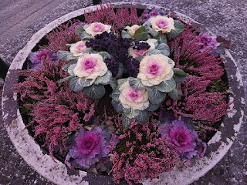

Everywhere we walked, I was in love. Iceland - particularly Reykjavik - is just so darn tootin' cute. It has the feel of Scandinavia, with charming cottages, fun storefront displays, cozy cafes and restaurants, and every color of the rainbow - EVERYWHERE.

Close to 11:00 a.m.now, and the sky was still trying to wake up . . .

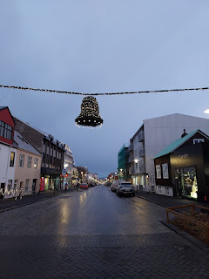

This was an unusual "Water Closet", or public bathroom next to the church . . .

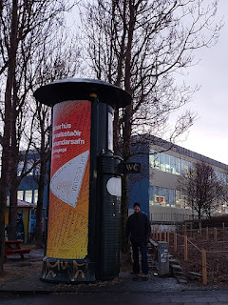

An example of the Scandinavian styled homes, with bright cheery colors . . .

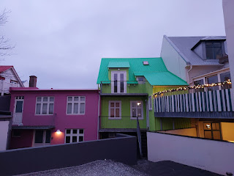

This was our first INTENDED stop: Braud & Co. Bakery.

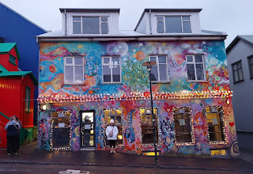

We watched an episode of "Somebody Feed Phil" (on Netflix) before we went to Iceland. Our son, Jacob, had first told us about this series. The main guy, Phil, was a writer for the show "Everybody Loves Raymond". He's quirky and fun, but this particular episode helped us to better visualize Reykjavik before we arrived. We decided right then and there to make our 2 days in Iceland be about FOOD. We narrowed down which places we wanted to visit, based on where Phil had eaten, and then we pinned those locations on Google Maps before we ever left Italy.

You can read about the restaurants he visited here, on a blog that summarizes the stops he made:

https://www.visiticeland.com/article/somebody-feed-phil-foodtrail

Even though I knew it would be naughty and carbolicious, I wanted a hot, fresh cinnamon roll with all of my heart. So Braud & Co. was our first planned stop of the day. I chose the basic cinnamon roll (this time), but man-oh-man I WILL BE BACK. This place was EPIC.

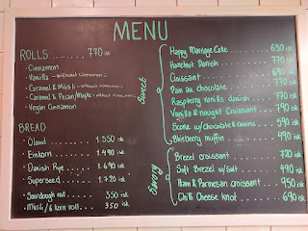

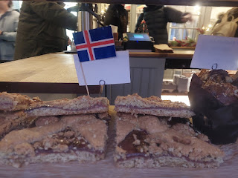

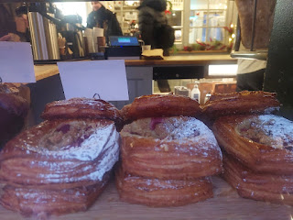

The shop was tiny, compared to the brightly painted storefront outside. There is only space for a few people at a time, and nowhere to sit inside. I would guess that most of the building houses the bakery portion, which doesn't leave much room to sell the baked goods up front. Most people would get their hot bread, of whatever variety, grab a coffee, and then stand outside to eat it from the paper bag it came in. So I did the same.

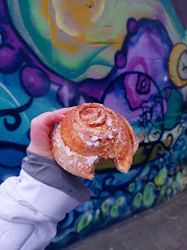

It wasn't a super thick cinnamon roll like what we're used to seeing in the U.S. It was smaller than I expected, but it had many, many layers of buttery flaky bread dough that just melted in your mouth. I'm drooling as I remember how it tasted in my mouth . . . Every bite was heavenly. It was warm. It was cinnamon-y. It was chewy. It was pure delight. And I WILL be back.

Next, we walked down to the waterfront area. The streets were hilly in parts, and narrow, similar to San Francisco, but way cuter.

Meant to be a replica of a Viking ship, this artistic creation is called, "Sun Voyager".

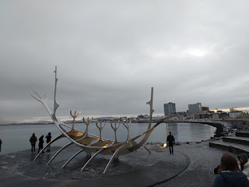

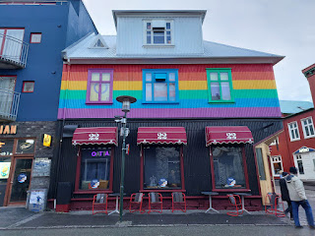

Colors, colors, everywhere. And my clever eyes spotted Santa Claus' underwear hanging up to dry on a clothesline . . .

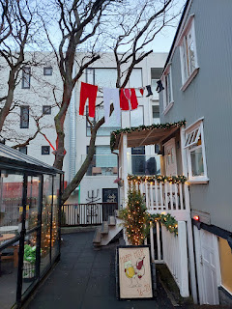

The Red Cross store was colorful and welcoming . . .

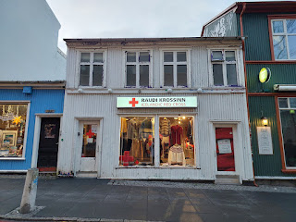

I saw this pretty color scheme arranged on a Christmas tree multiple times throughout the city, and even in the Keflavik Airport, but I can't seem to find any answers as to why the theme is orange socks and red bows.

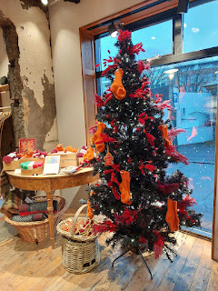

In the middle of the city, there is a stretch of road known as "Rainbow Road". So of course, we had to find it. :)

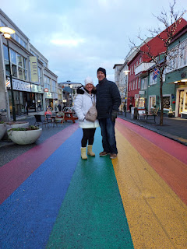

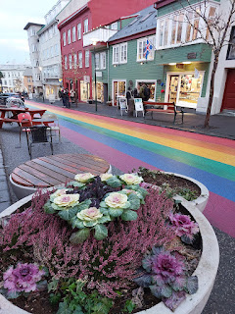

Looking up the street toward the Hallgrimskirkja Church . . .

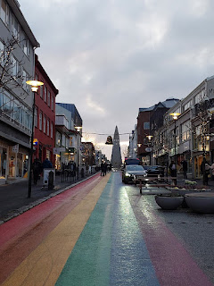

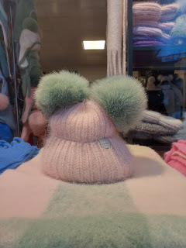

So many soft textures everywhere . . . I wanted to touch everything. One store had something called "Icelandic Wool Felted Soap." (click the photo below to read more about this)

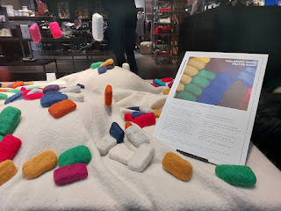

We saw a Dalmatian style storefront that was actually an Art Studio . . .

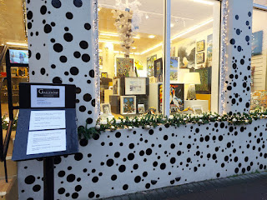

Colorful felted wool balls with sheepies stitched on the fronts, formed as a giant heart inside this shop window . . . I mean, how cute is that!?!

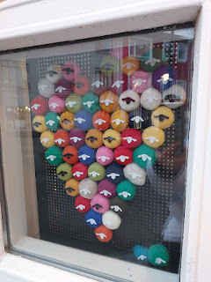

An example of how long the street names are in Iceland . . .

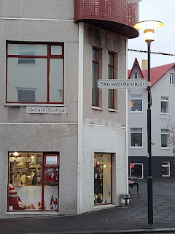

Lunchtime, and the sun is STILL trying to wake up fully . . .

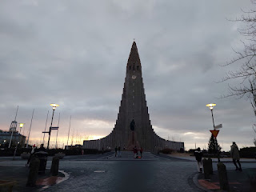

We walked back over toward the church because Scott's #1 food pick from the Somebody Feed Phil episode was this hot dog stand and we had to wait for them to open . . .

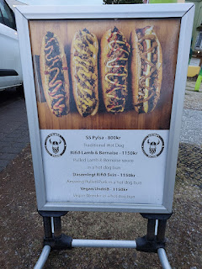

Vikinga Pylsur sits right next to the church, and consists of a tiny (and I mean TINY) trailer in a park-like setting, with picnic tables and benches to sit on. The menu is included on the photo above. (click to enlarge)

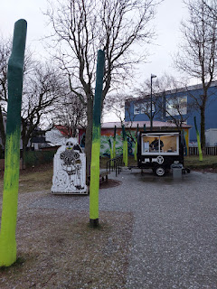

Scott wanted the pulled pork dog, but the guy told us his delivery guy hadn't brought the pork over yet. So he went for the next best thing: the pulled lamb (piled on top of the hot dog). Man was it amazing! Scott kept grunting those happy I'm-in-food-heaven sounds as he ate, occasionally making comments like, "This tastes like Thanksgiving!" He was able to identify something that tasted like sage in the lamb, and it reminded him of stuffing and baked turkey.

I grabbed the traditional dog, just so we had a different kind to share. The dog itself was perfectly crunchy on the outside and juicy warm on the inside. I didn't care for all the sauces on top, though. After Scott took a bite of it, I opted to just finish the hot dog part and ditch the bun (on account of the carbs). I had eaten a glorious cinnamon roll less than two hours earlier, so this was a good compromise.

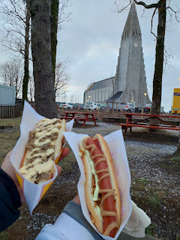

Video of a child swinging in brightly colored winter wear in front of the church next door: (4 seconds)

https://photos.app.goo.gl/JSqdzHLmAAjBpaSBA

Note that it was lunchtime and still not fully bright outside yet . . .

Our next stop was the Aurora Reykjavik Museum - all about the Northern Lights. It was a lengthy walk, but we found plenty to ooh and ahh over as we made our way there.

In the interest of time, I won't type up the information found on these signs that we passed by on Austurstraeti Street. But I promise they are very interesting!! They talk about how Iceland became independent in 1918, and how there is a long Danish history.

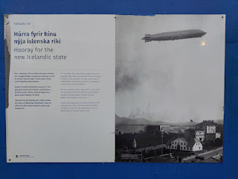

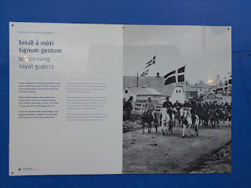

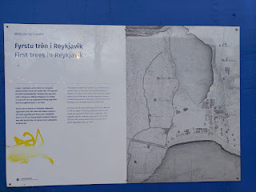

This is the story of the Christmas Cat . . . (English version)

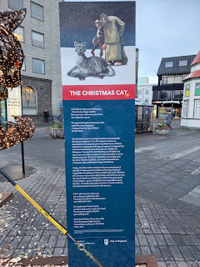

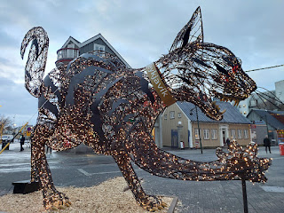

The Christmas Cat story is also printed in Icelandic on the opposite side . . .

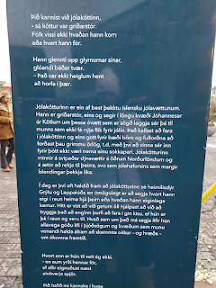

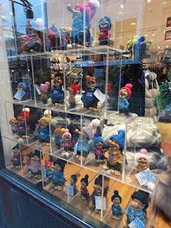

Cute little trolls in the storefront windows . . .

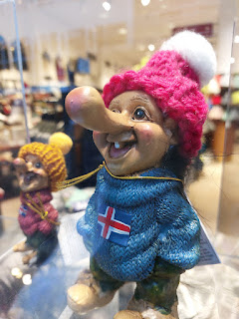

More informative signs - this one talks about influence of WWII on Reykjavik as the Brits arrived . . .

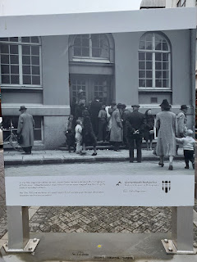

I'll insert this here instead of later: As I spoke with the young lady at the front desk in the Aurora Museum, she was a wealth of information and I ended up asking her several questions. She told me that the two airports on this side of the country (Keflavik - international, and Reykjavik - domestic) were built during WWII when the Americans and the British occupied Iceland and needed a way to get in and out. Nowadays, if there's ever a severe storm or a volcanic eruption, then the other airport is still able to be used. The only issue is that the Reykjavik Airport has a smaller runway, so some of the larger planes would not be able to land there.

I also asked her about the museums in Reykjavik and which one she liked the best. She told me that her favorite is the FlyOver Iceland, which is just one block from the Aurora Museum. If you have dizziness or vertigo issues, this may not be the best experience for you . . . But essentially, someone created a short "movie" of some drone footage while flying over different areas of Iceland. You pay to get into a chair that will move, simulating YOU flying WITH the drone. There's a huge movie screen that surrounds the seating in the theater, and she said it's a really cool experience.

I really enjoyed gleaning some lesser known nuggets of info about the background of Iceland from her.

Every June 17th, Iceland celebrates its National Day, as shown in this next poster . . .

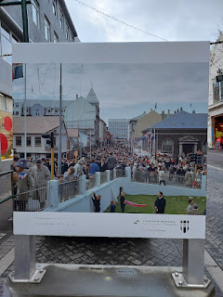

Video as we walked down the rest of that same street: (15 seconds) A very modern part of town.

https://photos.app.goo.gl/p3nKqmjss94ARbDq9

Video of the outdoor ice skating rink at the end of the street: (10 seconds)

https://photos.app.goo.gl/7weEp82jNySWb2HF8

Oh my bacon-y cuteness! A Christmas Pig?!! How delightful.

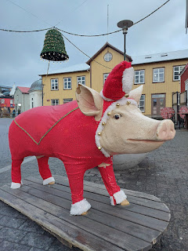

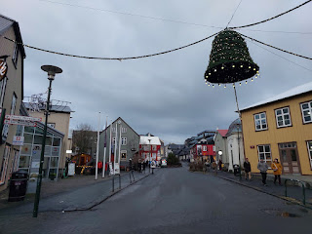

Here is a sign that explains the ancient trade industry during the 1700's and how this was the oldest street in Iceland, where the fishermen would make their way down to the harbor from their farms.

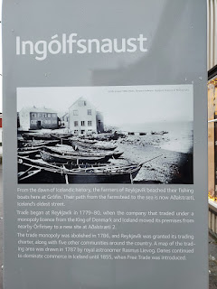

We passed by a statue of Leif Erikson, a Norse explorer who is said to be one of the first Europeans to discover America in roughly 1000 AD. He discovered it quite by accident, being blown way off course as he tried to sail home to Greenland from Norway.

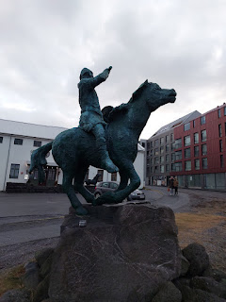

And finally, we arrived at the Aurora Reykjavik Museum, a museum dedicated to the beauty and the science behind the Northern Lights.

Thankfully, there were lots of comfy leather couches to sit on and rest in each room. We were tired from such a long walk. In the first room, you can opt to get your photo taken with the Northern Lights in the background and then it will be emailed to you. (I've included that photo a little further down below)

I loved reading about all of the different myths and legends regarding the Northern Lights, depending on which country you were from. Feel free to learn more by clicking on the photos below.

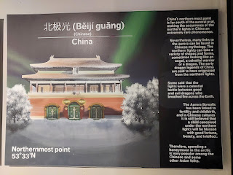

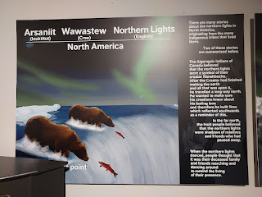

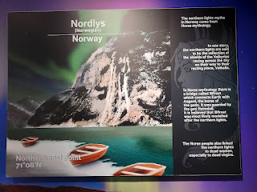

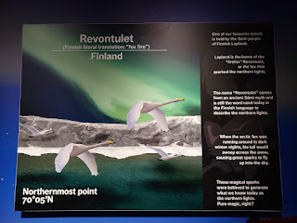

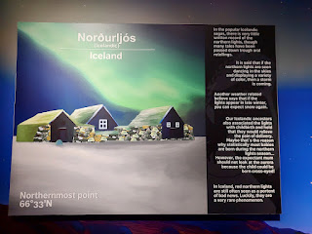

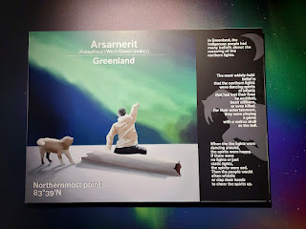

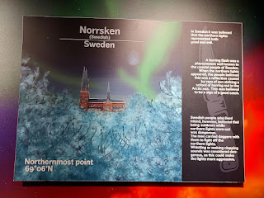

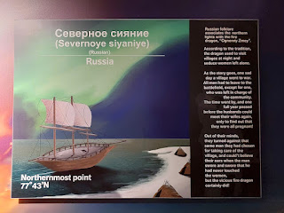

There were several opportunities to learn the science behind the Northern Lights, which was truly fascinating.

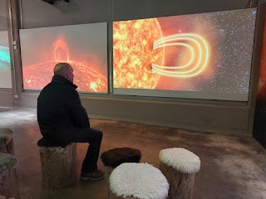

This is a nutshell version of what happens in the process . . .

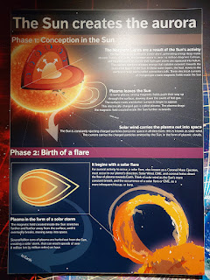

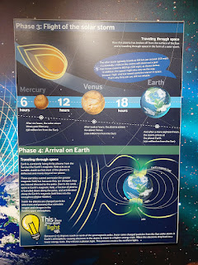

There is another room to help you figure out where and how to get the best photos of the Northern Lights, including a map with popular locations and a booth to help you get the right settings on your camera ahead of time.

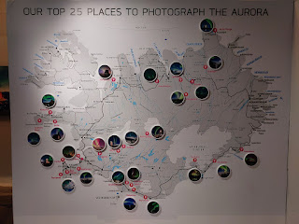

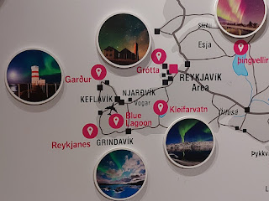

There was even an Aurora Forecast - similar to a weather forecast. For Tuesday, the day that we were there, it said that our chances were somewhat low at a "2". The next photo will explain the number scale better.

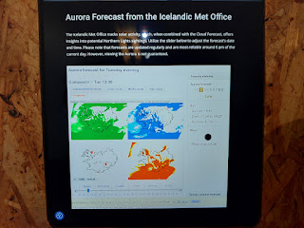

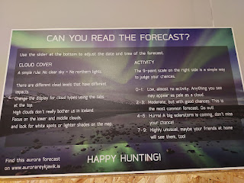

At the back of the museum, there is a "chillout room" where the lights are dimmed, relaxing music is playing in the background, and a 30-minute movie is playing with different scenes of the Northern Lights around Iceland. You can either choose to sit in a chair while you watch, or lay on the floor on top of a beanbag bed.

I opted for the beanbag bed on the floor . . . it felt so amazing to just lay there and relax for a while. Plus, nobody else was in the museum except for us that afternoon. So we had this room all to ourselves.

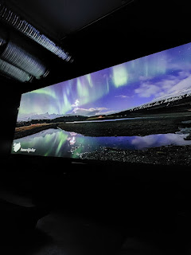

A few of the scenes from the movie . . .

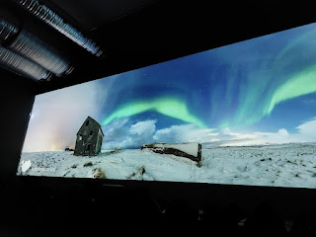

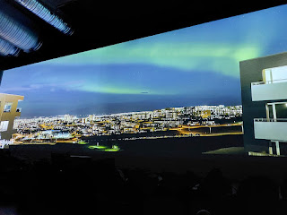

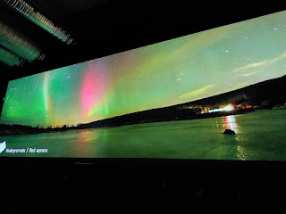

If you need a moment to relax, perhaps you'd like to watch this 54-second video of the Northern Lights:

https://photos.app.goo.gl/uY2uraAf7XgShqxg8

How I wish we had been able to see the Northern Lights for real. It is still something on my Bucket List.

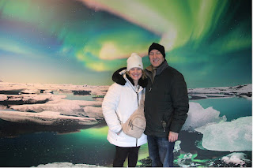

Even though I never wanted to leave that dark and relaxing theater, we had seen all that we came to see. We had a 35 minute walk back to our car, which allowed us to walk along the shoreline for a few minutes. It was beautiful, even though the sky was moody and cloudy.

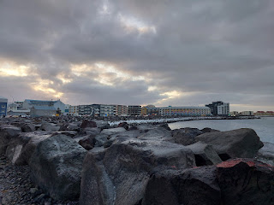

They sure know how to repurpose lava rocks in Iceland . . . we saw them everywhere. Small black gravel paths, landscaping, and borders. Black sand next to the water's edge. And even put to use as a dyke or barrier to the sea itself.

Video of the lava rock shoreline: (11 seconds)

https://photos.app.goo.gl/SXY2htR1cAPDXD5m6

For those of you who like Super Mario . . . this painted wall in Reykjavik would bring a smile to your face.

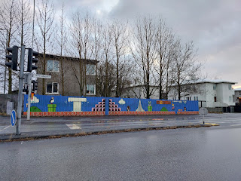

We popped into a local cemetery across from the University and the parking lot where we had parked earlier. I was curious to see what their setup is in Iceland, like do they have small plots that get recycled in 25 years like they do in Switzerland? But no, that's not what I saw.

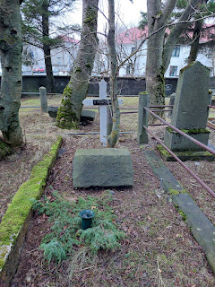

These cemetery plots were full-sized and several decades old. The oldest headstones that we found were for people who were born in the 1860's and died in the 1920's and 1930's. Some headstones were completely filled in with moss where the words should be.

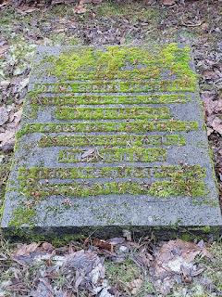

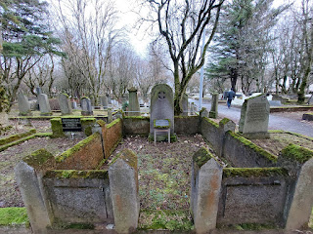

With the Danish heritage, pretty much everyone's names end with "son" or "dotter". Son of John = Johnson. Daughter of Halldor = Halldorsdottir. (as seen in the photo below this next one)

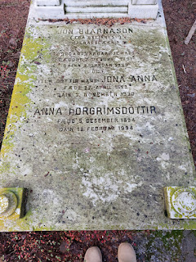

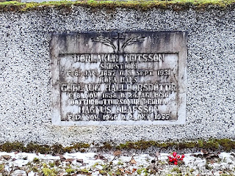

After we had the car back at our disposal, we drove across town and parked near the SeaBaron Restaurant to eat an early dinner. This was another place from the episode of Somebody Feed Phil. I wanted the Lobster Soup!!

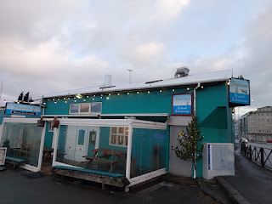

The menu was on the wall as you walk in . . . options included: Skewers of salmon, wolf fish, shrimp, blueling, potatoes, or vegetables. Or you could choose the lobster soup (yup) or a nugget of traditional fermented shark (nope).

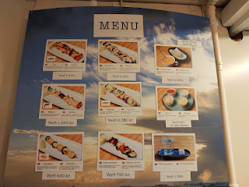

I ordered the lobster soup, and a skewer each of the wolf fish and the vegetables. The soup arrived right away, piping hot and steamy with warm bread on the side.

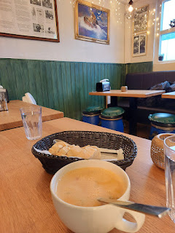

Video of the yummy soup: (7 seconds)

https://photos.app.goo.gl/vdPMcDvfMSuQu3wF8

The skewers of fish and veggies came out a few minutes later. They were equally delicious. I was very happy with what I ordered.

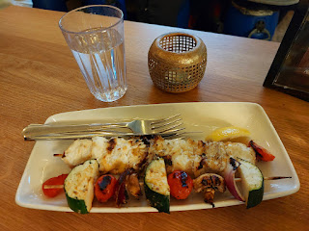

My husband is a funny guy sometimes. Like in this instance. For some reason, he has "decided" that he only eats a large breakfast and a large dinner, with maybe just a spoonful of peanut butter for lunch (when he's at work back in Vicenza). When he "decides" that he "doesn't" eat lunch, he refuses to order anything if we're at a restaurant together during the lunch hour. But what he DOES do sometimes, is he snitches at whatever

I've

ordered. Sometimes he just drinks water and watches me eat, too, which I don't really like either. I've tried to tell him that: 1) it's best to eat several smaller meals throughout the day; 2) in Italy especially, the server is visibly uncomfortable when we have come to their restaurant but he (Scott) doesn't want to order anything; 3) it's uncomfortable for me when I'm the only one eating and he's just sitting there; and 4) maybe I don't

want

to share my food, LOL.

Ultimately, because I love him with all of my heart, I end up sharing my food anyway, which is what I did in this case. He tried a spoonful of the soup and then he let me savor the rest, which I 100% enjoyed. He snitched about half of my wolf fish and veggies, but I figured he needed some nourishment, so I didn't say a word. :)

Before we left the restaurant, there was a poster on the wall showing all the local fish in the Icelandic Sea. We searched carefully to find the Steinbitur - which is also known as Wolf Fish. See if you can find it below.

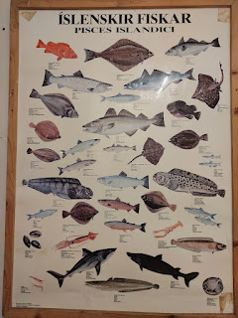

This guy. XOXO. As we walked back to our car to go to the grocery store next, he paused to discuss the geometrical designs in the windows of an office building as we passed by.

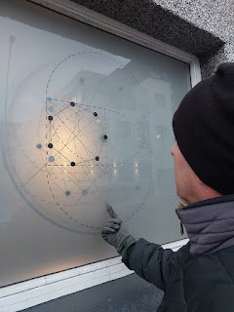

His brain is so incredibly smart. Sometimes I feel dumb and insignificant compared to how smart he is, but not because he makes me feel this way. Recently, I melted into tears because I felt like I won't be much use in the next life. He has a brain that is ready to design and build and he understands science and math and physics and stuff. My brain is more focused on how can I make something pretty, or ooh - this tastes really good, or maybe I want to clarify some information on the internet or ChatGPT for my blog. But I don't think those things will be really necessary in the next life . . .

Anyway, I just marvel at his intellect so many times.

We stopped at the grocery store (Kronan Granda) near the Aurora Museum after our light dinner. We grabbed a few things to haul to the U.S., along with a giant panini sandwich from the deli for Scott and a yogurt bowl for me (with fruit, oats and peanut butter).

I saved my receipt because I wanted to share how much things cost in Iceland.

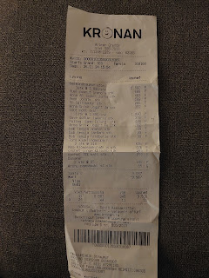

The total amount of 9587 krona is equal to $69.34 in USD for November 26, 2024. Each day, the rate is slightly different, so I had to be specific in my question to Chat GPT. We bought a sandwich, a yogurt bowl, a banana, a couple of extra yogurts, some granola and milk, and some chocolate. We also bought a couple of soup mix packets. So not very much overall. $70 for what we brought back to the hotel room seemed like a lot, but we were happy to have any food on that mostly deserted island with a volcano erupting nearby. :)

Speaking of volcano, I marveled at how fun it was to see the lava spewing each day, like we were checking on our little lava baby or something. How's he doing today? Oh good, he's still there, and he's still spewing.

There was a little hill or bluff near our hotel, and we parked up there for a few minutes to get a better view before we drove "home" for the night.

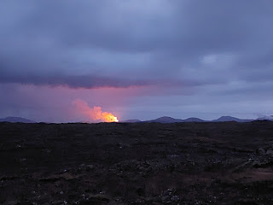

Video of the colorful spewage: (36 seconds)

https://photos.app.goo.gl/jus9QCBgFssHmznE8

Wednesday, November 27th:

We had really chatted ourselves up about going back to Reykjavik the following day to finish seeing some of the things we didn't get to the day before, but the next morning we realized that this wasn't the wisest itinerary. It only takes about 40 minutes to get from our hotel to Reykjavik, but that doesn't include all the gnarly traffic.

We were quite surprised the day before as we drove into the city at how many people were on the roads. We did a quick internet search and learned that the population of the city itself is roughly 140,000 in 2024. This does not include the towns and villages that surround Reykjavik. Approximately 2/3 of the entire population of Iceland lives in Reykjavik! With the University and an abundance of tourists (like us), the number of people driving around goes up even more.

We would have spent a good hour just to get into the city and park the car, plus another hour to get back. That wouldn't leave much time to play, and we'd be far away from the airport (our flight was later that afternoon). So we decided to find some things to see in Keflavik instead, which was only 10 minutes away and home to the international airport, too.

The skies were very pretty on our short drive to Keflavik.

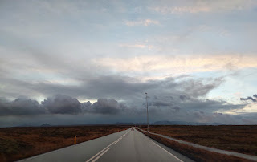

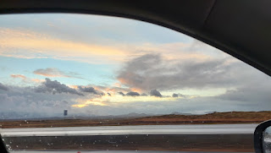

The sea was on our right and included some handsome marshes along the shoreline.

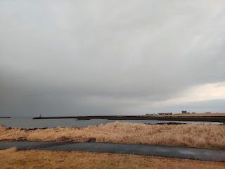

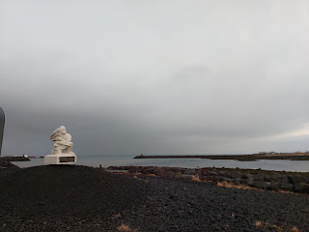

We decided to visit the Viking World Museum first, since that would take the longest amount of time. Everything after that could be prioritized, once we knew how much time we had leftover before we had to be at the airport. It's located on a tiny peninsula which is part of a small protected harbor (from the harsh Norwegian and Labrador Seas).

The most popular feature of this museum is that they have a replica of a 9th century Viking ship right in the center of the building. At the ticket counter, there is a souvenir list of Viking Laws that you might want to look over before we begin . . .

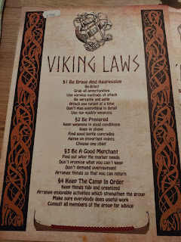

An intriguing board game was set up and ready, called Nefatavl. The instructions are below. The play reminds me a little of both chess and checkers.

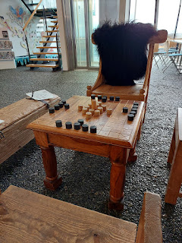

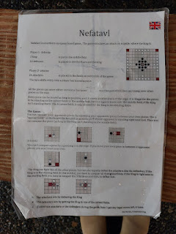

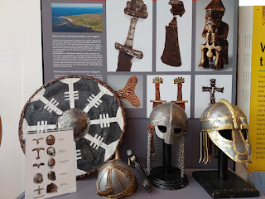

10th century headwear has been recovered from places such as Denmark, Ukraine, Sweden, and Norway. You can even try the helmets on, but some of them are extremely heavy.

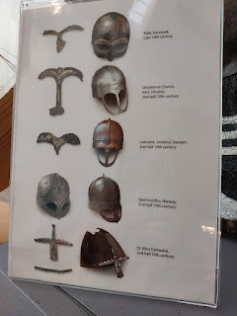

I chose a lightweight plastic horned helmet . . .

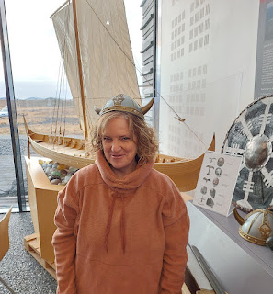

The next 3 photos discuss the history of the Vikings from Norway. They had a profound influence across many lands and seas. You can click on the photos to read more.

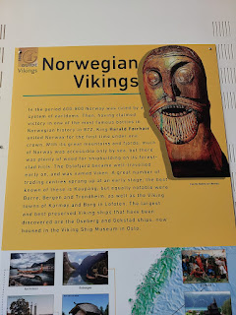

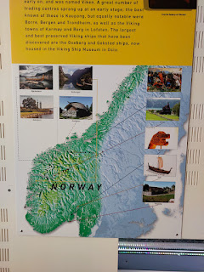

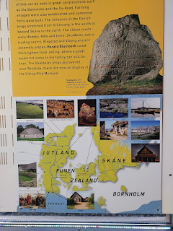

This next sign shares more details about Leif Erikson and his accidental discovery of North America.

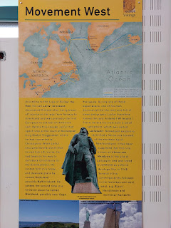

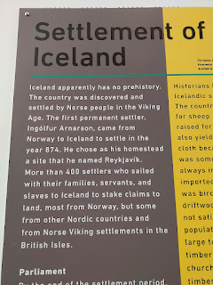

Norway is believed to be the first nationality to inhabit Iceland, although Denmark became the ruling government later on. I loved reading about what the Icelanders ate and how wool fabric became their top export.

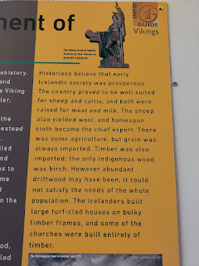

Here is a map made in 1590, with drawings of mythical sea creatures and evidence of active volcanoes.

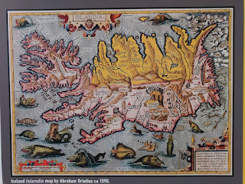

A 9th century Viking ship was found in a burial mound in Gokstad, Norway. It was painstakingly recovered and is now on display in a Viking museum in Oslo, Norway.

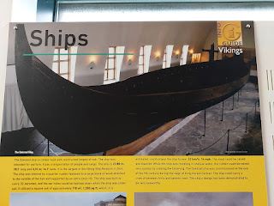

I enjoyed reading about what the early vikings wore, as they would have had to keep warm for much of the year but also needed functionality for their daily chores.

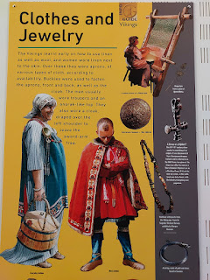

What the men traditionally wore . . .

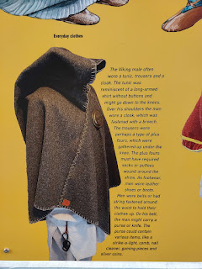

What the women traditionally wore . . .

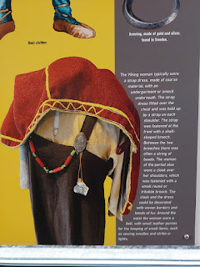

Typical foods that they ate, including Skyr (a type of yogurt that we see in the grocery stores today), and how they preserved their foods . . .

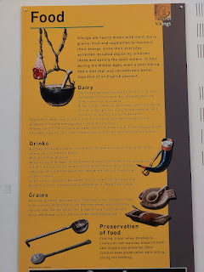

Upstairs provides an access to the Viking ship . . .

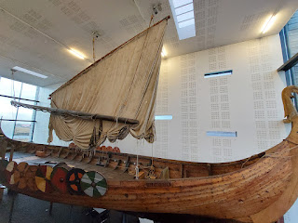

Video of the length of the ship: (13 seconds)

https://photos.app.goo.gl/dZAFJkpK2aCbcGNs6

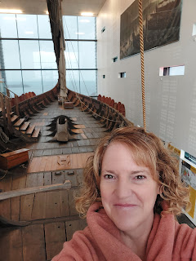

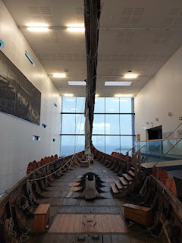

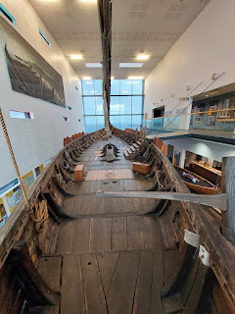

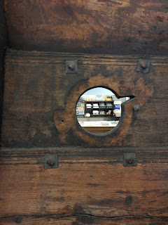

This replica ship, named Islendingur, was built for the purpose of recreating the original founding voyage to North America. The memorial sailing to Newfoundland took place in 2000. The crew are pictured below.

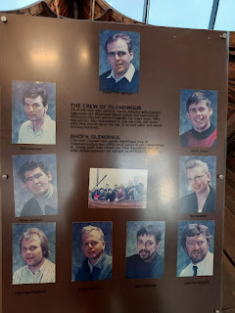

What a historical journey! The man who built the boat is a descendant of Leif Erikson and wanted to recreate the experience to educate children about their important history. You can read more about their adventure on Wikipedia:

https://en.wikipedia.org/wiki/%C3%8Dslendingur

Of course, sailing across the sea many centuries ago inevitably came with a darker side to have to deal with . . .

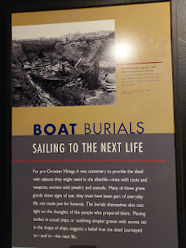

As an avid family history fan, I'm always curious about what other cultures believe about the afterlife. In the case of the Vikings, they believed that the deceased needed tools and supplies to not only GET them to the next world, but to help them survive there as well.

Next to the photo - within the photo below - it says (in small print):

"Viking Age Cemetery - Lindholm Hoje, Jutland, Denmark.

Two hundred graves were marked with stones set in the shape of ships. Although less extravagant than the royal ship burials at Gokstad and Oseburg, these symbols were meant to transport the deceased to and in the other world. This Scandinavian custom, known since the Bronze Age, is still practiced by some Siberian people."

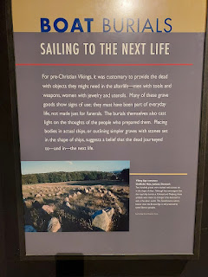

A visual replica of how a deceased loved one would have been sent off into the next world . . .

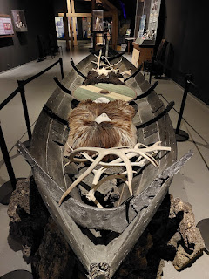

Some very fascinating details about a wealthy woman and the fancy nature of her burial in 834 AD . . .

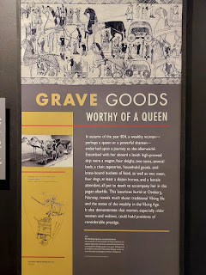

We enjoyed the Viking World Museum very much. We spent approximately one hour here and it felt just right. If we had had kids with us, we would have spent a little longer.

There was a hint of a rainbow as we drove into town, and it looked like it originated straight out of the museum! Also, there are some thatched roof huts outside that you can explore as part of the museum experience, but it was rainy and windy so we opted to skip that part, sadly.

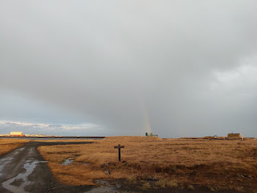

Rick Steves has said on his Iceland episode (filmed in July 2024 and available on YouTube), "If you don't like the weather in Iceland, just wait 5 minutes." And it's true. In the five minutes it took us to drive to our next stop, the rain had stopped and the sky was more clear.

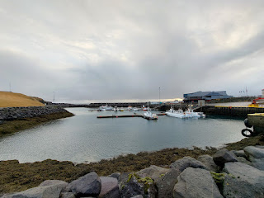

I laughed out loud when I read about this mythical cave in Keflavik. It's known as Giganta's Cave, or Cave of the Giantess.

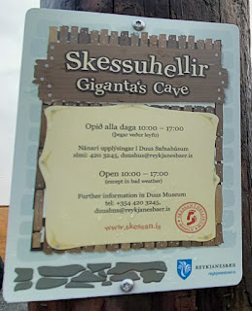

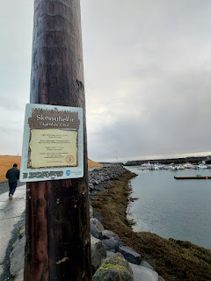

A travel writer from Iceland has written all about the gigantic troll on her website, including some excerpts from the lovely children's books about Sigga and the Giantess (16 in all). It is a delightful read, I promise!

https://guidetoiceland.is/connect-with-locals/regina/sigga-the-giantess-in-the-cave-in-keflavik-town

Massive footprints lead you to the cave . . . you really can't miss it.

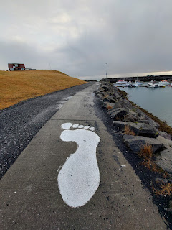

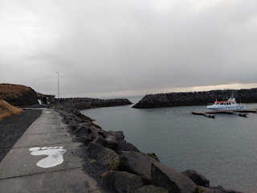

Me, all kinds of terrified of what I might find inside the cave . . .

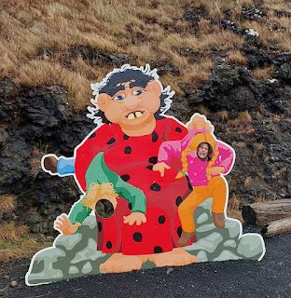

There is a huge oversized adirondack chair out front, no doubt where the Giantess likes to sit in the sun from time to time.

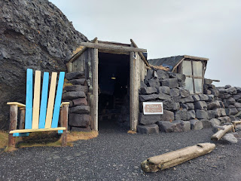

While I explored the cave, Scott wanted to climb on the lava rocks outside the cave . . . typical boy.

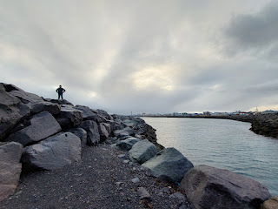

Video of the first half of the cave: (31 seconds) You can see the postal box where you can leave a letter for the Giantess, and the little tree in the back of the cave where little ones can leave their pacifier when it's time to "graduate", ha ha.

https://photos.app.goo.gl/zHhqicMy5TGqAsdSA

Her gigantic toothbrush, shoes, bed, etc.

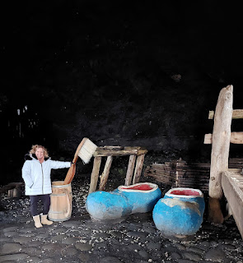

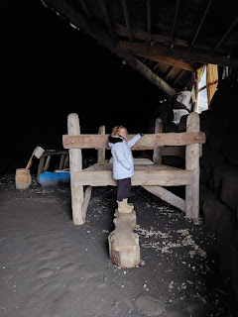

Video coming in from the other cave opening: (15 seconds) You can hear some of her snoring in the background.

https://photos.app.goo.gl/be9tGr1ftmxgtrNe8

When I brought Scott in a few minutes later, we heard her not only burp a couple of times, but she also tooted in her sleep, LOL.

It was a place that I would definitely want to take my grandchildren, if we are ever so fortunate as to bring them to Iceland some day. I think they would get a kick out of this for sure. I want to see if the stories of Sigga are in English, too, because they could help set the stage for a future visit.

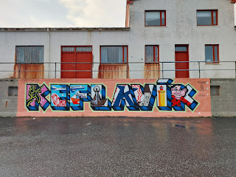

From here, we drove into town (Keflavik is not very big at all) to have some lunch at a place that I chose, called the Kef Restaurant. It's a fancier cafe that is attached to a very nice hotel next door - Hotel Keflavik. The reason I chose this was because they had seafood options and I really wanted something fresh before we flew away from this beautiful country on the edge of the sea.

I somehow convinced Scott to order something: pulled pork tacos.

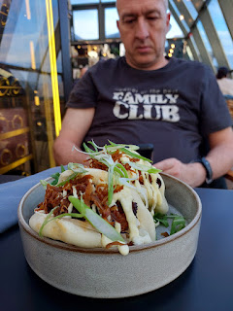

I ordered the fish and chips and it was probably the best fish and chips I've ever had.

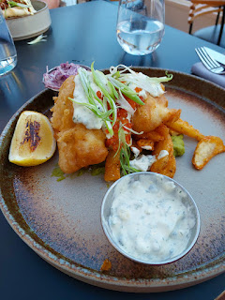

The lemon wedge was gently charred, the coleslaw was delicate and mild, the fish was perfectly crispy on the outside and tender on the inside, and the seasoned fries were underneath the fish along with the mushy peas (as the English would call it). They were also very yummy. I cleaned my plate up, with the exception of eating all of the tartar sauce. I didn't need to slurp it all down because the fish tasted so good on its own.

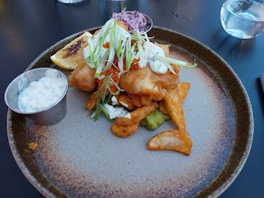

And then, it was time to turn in our rental car and get checked in at the airport. It was blustery, a little rainy, and freezing cold as we left Iceland. But I didn't care.

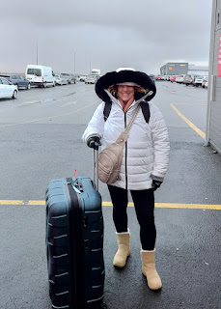

I loved every minute of Iceland and I can't wait to go back! I have a long wishlist of things I want to do and places I want to see. Given the fact that there is a cheap and direct flight from Italy to Iceland, and another cheap and direct flight from Iceland to Minneapolis, I think this will end up being a very popular route for us in the future. There's even a direct flight from Reykjavik to Portland!!

We had a nice, quiet 6-hour flight to Minneapolis where we were able to finally meet our newest granddaughter, Maisie. I'll share more about that in my next post.

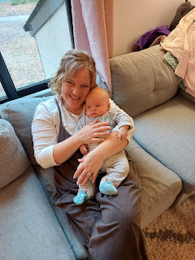

Being a Grandma is the BEST. XOXO